**Lab 3**

**Inductive Reactance**

**Objective**

Inductive reactance will be examined in this exercise. In particular, its relationship to inductance and frequency will be investigated, including a plot of inductive reactance versus frequency.

**Theory Overview**

The current – voltage characteristic of an inductor is unlike that of typical resistors. While resistors show a constant resistance value over a wide range of frequencies, the equivalent ohmic value for an inductor, known as inductive reactance, is directly proportional to frequency. The inductive reactance may be computed via the formula:

XL= j 2πfL

The magnitude of inductive reactance may be determined experimentally by feeding an inductor a known current, measuring the resulting voltage, and dividing the two, following Ohm’s Law. This process may be repeated across a range of frequencies in order to obtain a plot of inductive reactance versus frequency. An AC current source may be approximated by placing a large resistance in series with an AC voltage, the resistance being considerably larger than the maximum reactance expected.

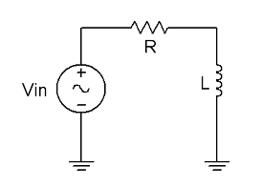

**Equipment**

1. AC Function Generator
2. Oscilloscope
3. DMM

**Components**

1. 1 mH actual:__________________
2. 10 mH actual:__________________
3. 10 kΩ actual:__________________

**Procedure Figure 1**

**Current Source**

1. Using Figure 1 with Vin=10 Vp-p and R=10 kΩ, and assuming that the reactance of the inductor is much smaller than 10k and can be ignored, determine the circulating current using measured component values and record in Table 1. Also, measure the DC coil resistances of the inductors using an ohmmeter or DMM and record in Table 5.1.

**Measuring Reactance**

1. Build the circuit of Figure 1 using R=10 kΩ, and L=10 mH. Place one probe across the generator and another across the inductor. Set the generator to a 1000 Hz sine wave and 10Vp-p. Make sure that the Bandwidth Limit of the oscilloscope is engaged for both channels. This will reduce the signal noise and make for more accurate readings.
2. Calculate the theoretical value of XL using the measured inductor value and record in Table2.
3. Record the peak-to-peak inductor voltage and record in Table 2.
4. Using the source current from Table 1 and the measured inductor voltage, determine the experimental reactance and record it in Table 2. Also compute and record the deviation.
5. Repeat steps three through five for the remaining frequencies of Table 2.
6. Replace the 10 mH inductor with the 1mH unit and repeat steps two through six, recording results in Table 3.
7. Using the data of Tables 2 and 3, create plots of inductive reactance versus frequency.

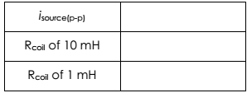

Table 1

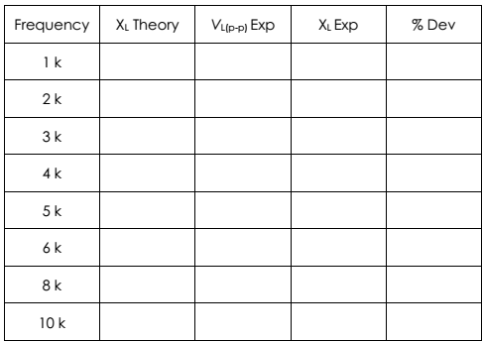

Table 2

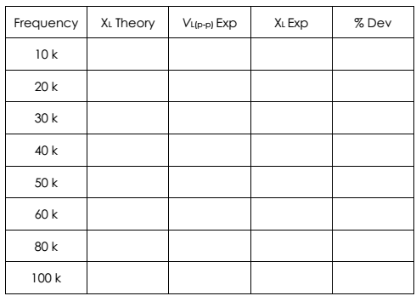

Table 3